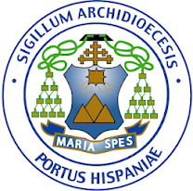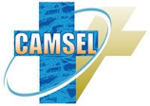

Catholic Media Services Ltd
The Catholic Centre, 31 Independence Square, Port of Spain, Trinidad
Tel: 1-868-623-7620 • Fax: 1-868-623-9468 • E-mail: camsel@catholictt.org

NOTICE ISSUED BY THE ROMAN CATHOLIC ARCHDIOCESE OF PORT OF SPAIN

The Roman Catholic Archdiocese of Port of Spain has noted with grave concern, videos recently published on social media in which two young women made allegations against a monk formerly associated with the Mount Saint Benedict Monastery and St. Bede’s Vocational School.

We acknowledge that the loss of innocence of any child through any form of abuse is a tragedy, a deep and lasting wound for the victim as well as a serious crime. Our prayers and support go out to the young women and Mount Saint Benedict community at this time.

We understand that the allegations raised in these videos are under review by the Trustees of Mount Saint Benedict and that the Brother in question left the monastic life some years ago and is no longer a member of the community of Mount St. Benedict. We understand also that one of the women has been contacted by the Trustees of the Monastery following the publication of the videos.

We stand committed to ensuring that all our spaces are safe and will work tirelessly to protect our children in their interactions with the Roman Catholic Church in Trinidad and Tobago.

29th June 2020

